CSE PROJECT REPORT

Project Report
TIC-TAC-TOE GAME

Name – AMAN AGARWAL
Reg no.- 25BCY10069
Course: INTRODUCTION TO PROGRAMMING PROBLEM(PYTHON)

Introduction
What is Tic-Tac-Toe?
Tic-Tac-Toe is a simple 2-player strategy game played on a 3×3 grid where players alternately place symbols (X and O) and try to get three in a row horizontally, vertically, or diagonally. It is widely used as an introductory programming project because the rules are simple but still require logic, loops, and condition checking.
Aim of the project
The aim of this project is to implement the classic Tic-Tac-Toe game using Python so that two players can play interactively on a computer. The project focuses on practicing basic Python concepts such as lists, functions, conditional statements, and loops, and optionally simple GUI concepts if Tkinter is used.
Tools and technologies
The core technology used is the Python programming language, which handles the game logic, input, and win/draw detection. Depending on your version, the interface can be text-based in the terminal or built using the Tkinter GUI library to create buttons and labels for the 3×3 board.
Project scope and features
The project includes features such as displaying a 3×3 board, taking turns between Player X and Player O, checking for winning combinations, and detecting a draw when the board is full. You can also add extra features like input validation, replay option, and a simple menu or scoreboard to make the game more user-friendly.
Implementation
The implementation of Tic Tac Toe in Python follows simple logic: it sets up a game board, allows two players to take turns placing their marks ('X' or 'O'), and checks after each move if a player has won or if the game is a draw.
The core logic involves loops for input and game progression, conditionals for checking wins or invalid moves, and simple data structures to represent the board. This makes the implementation clear, easy to understand, and suitable for beginner programmers.
This approach can be extended with additional features like AI for single-player mode or a graphical interface for better user experience.

Algorithm/Design
1.Initialize the board as a 3x3 grid filled with empty spaces.
2.Set the current player to 'X' (or 'O').
3.Loop until the game ends:
->Display the current state of the board.
->Ask the current player to choose a position (row and column).
->Check if the chosen cell is empty; if not, ask again.
->Place the player's mark on the board.
->Check if this move causes the player to win (3 in a row horizontally, vertically, or diagonally).
If yes, declare the player the winner and end the game.
->Check if the board is full (draw).
If yes, declare a draw and end the game.
->Switch the current player ('X' changes to 'O' and vice versa).

Testing & Output
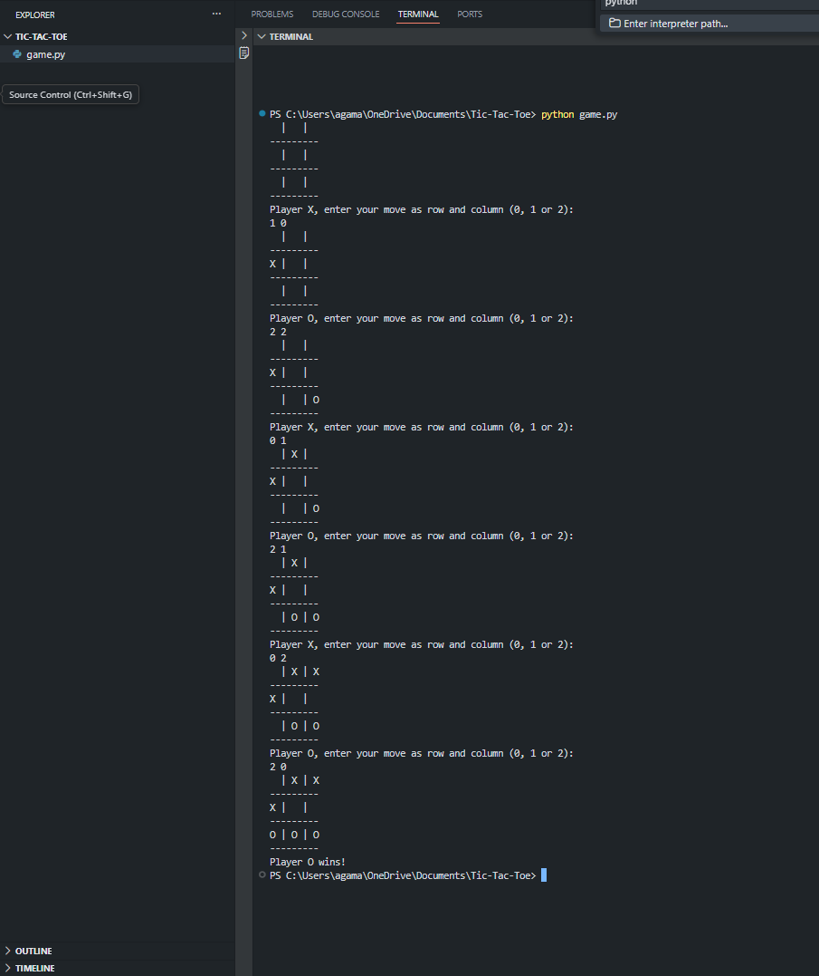
Code
